1. Spring provides some built-in filter classes which we can extend.
2. 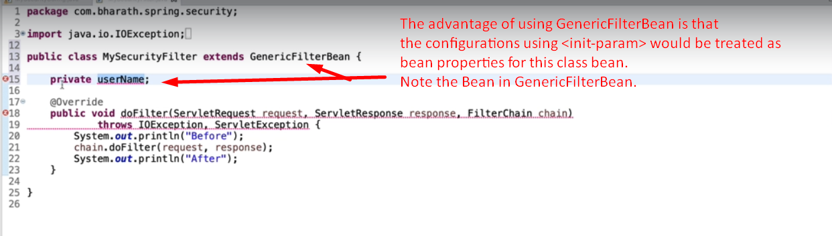
3. 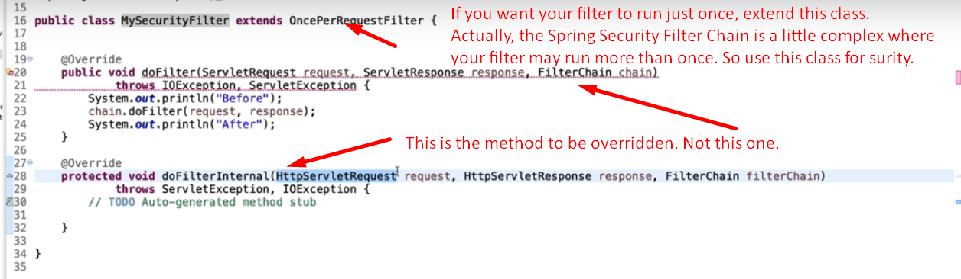
4. NOTE: Even though, it says just once but it’s our responsibility that we write such logic that it runs once.